Exercise: 4a Conduct task analysis for an app Date:29.03.2025

(e.g., food ordering app) and document user flows.

Create corresponding wireframes using Lucidchart

AIM: To understand and document the steps a user takes to complete the main tasks within an online shopping app.

Procedure:

**Step 1: Assigning Tasks**

1. **User Login & Location Access**
2. **Browsing or Searching Restaurants**
3. **Adding Dishes to the Cart**
4. **Final Checkout & Payment**

**Step 2: Document User Flows**

**1. User Login & Location Access**

1. User opens the food delivery app.
2. The app prompts to either log in or sign up.
3. If logging in, user enters mobile number.
4. If signing up, user provides name and address.
5. The app checks if location access is needed.
6. If Yes, user is asked for permission.
7. If No, user manually enters their area.
8. The app validates the location.
9. If valid, the restaurant list is displayed.

**Open food app** → **Login or Sign Up** → *(Login)* → **Enter Mobile Number**→ *(Sign Up)* → **Enter Name & Address** → **Location Access Required?**→ *(Yes)* → **Allow Location Permission** → *(or No)* → **Manually Enter Area**→ **Valid Location?** → **Show Restaurant List**

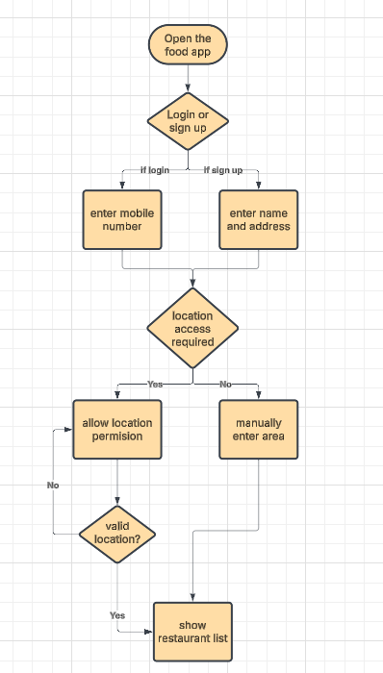

**2. Browsing or Searching Restaurants**

1. User lands on the homepage.
2. They choose to either browse the menu or use the search bar.
3. If browsing, they select from restaurant categories.
4. If searching, they enter the name of the dish or restaurant.
5. They apply filters like cuisine or dietary preferences.
6. They view restaurant or dish details.

**Open Homepage** → **Browse or Search**  
→ *(Browse)* → **View Restaurant Categories**→ *(Search)* → **Search for Specific Dish or Restaurant**→ **Apply Cuisine or Dish Filter** → **View Dish or Restaurant Details** → **End**

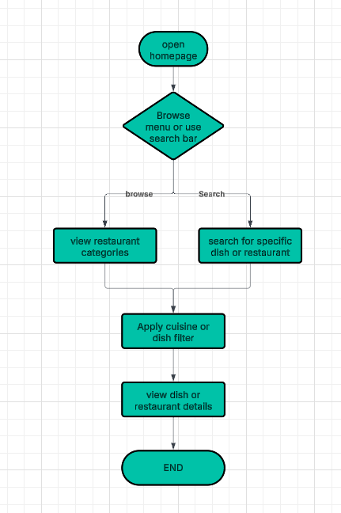

**3. Adding Dishes to the Cart**

1. User taps “Add to Cart” on a dish.
2. The app checks if a cart already exists.
3. If Yes, user views current cart summary.
4. If No, a new cart is created.
5. User sees cart summary.
6. App prompts user to apply a promo code.
7. If Yes, they enter promo code.
8. If No, they skip.
9. User selects a delivery address.

**Add to Cart** → **Already Has Items?**→ *(Yes)* → **View Cart Summary**→ *(No)* → **Create New Cart** → **View Cart Summary**→ **Apply Promo Code?**→ *(Yes)* → **Enter Promo Code**→ *(No)* → **Skip**→ **Select Delivery Address** → **End**

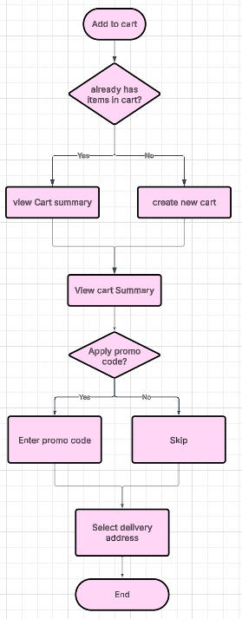

**4. Final Checkout & Payment**

1. User selects the payment method.
2. Then chooses a delivery time slot.
3. The app asks: COD or online payment?
4. If COD, user places the order.
5. If online, user is redirected to a payment gateway.
6. After confirming payment, user sees order confirmation screen.

**Start** → **Select Payment Method** → **Choose Delivery Time Slot**→ **COD or Online Payment?**  
→ *(COD)* → **Place Order**→ *(Online)* → **Redirect to Payment Gateway** → **Confirm Payment**  
→ **Order Confirmed Screen** → **End**